**Batch: D - 1 Roll No.: 16010122096**

**Experiment No. 02**

|  |
| --- |
| **TITLE**: Design and render the object (Nature, Household, mechanical or other) |

**AIM:**

Design and render the object (Nature, Household, mechanical or other)

Students Needs to check allotment from list of objects and design-render.(List is given on LMS)

**____________________________________________________________________**

**Expected OUTCOME of Experiment:**

Understand the computer Input & interaction, Curves and Computer Animation in Blender. **_____________________________________________________________________**

**Books/ Journals/ Websites referred:**

Youtube

**_____________________________________________________________________**

**Steps to perform:**

1. Set Up Your Workspace

2. Create the Base of the Lantern

3. Create the Body of the Lantern

4. Add the Glass Panels

5. Create the Top of the Lantern

6. Add Details (Handles, Hinges, etc.)

7. Apply Materials and Textures

8. Set Up Lighting

9. Render Your Scene

Drive or GitHub/google drive link:

**Output(s) (Screen Shots):**

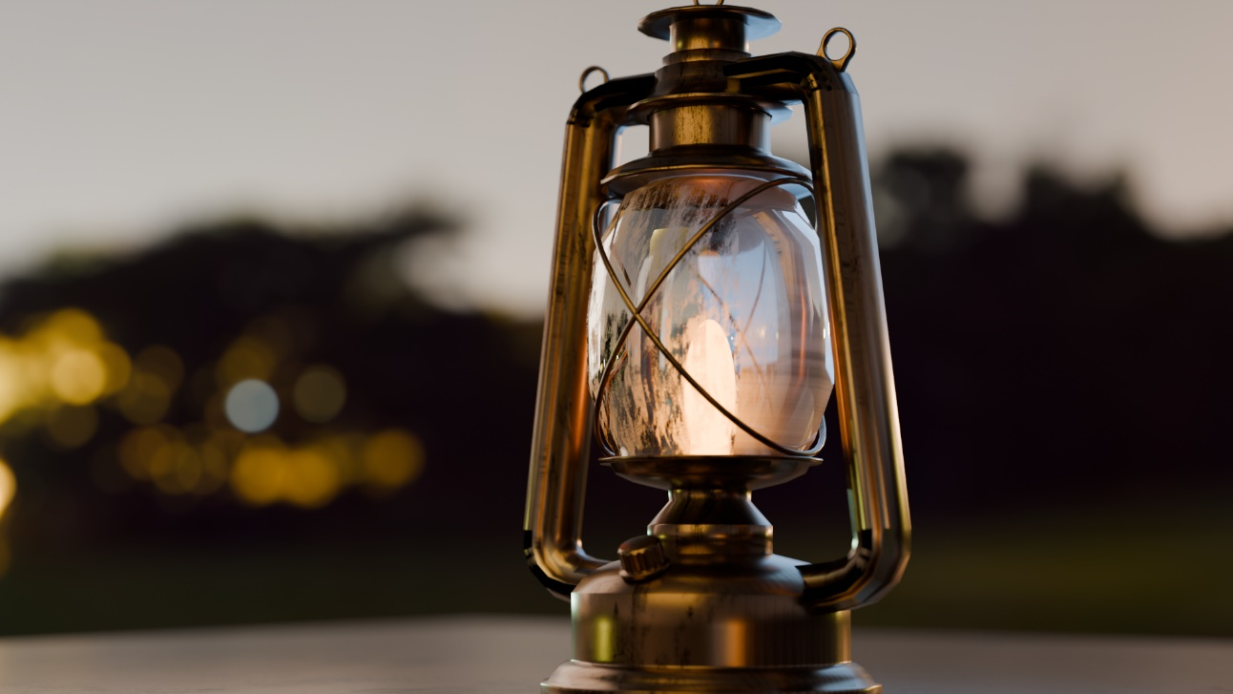

**Lantern:**

<https://drive.google.com/file/d/1E8vnHVrlKk_zMqiKs5Myh3hDgDd2fqp/view?usp=drive_link>

**Conclusion and discussion:**

In this experiment, I designed and rendered a lantern using Blender, which significantly improved my 3D modeling and rendering skills. I tackled challenges related to scaling, texturing, and lighting, and overcame them through iterative adjustments. This project enhanced my understanding of digital design and laid the groundwork for exploring more advanced rendering techniques in the future.

**Date: 06 / 08 / 2024 Signature of faculty in-charge**